**MINUTES ANNUAL GENERAL MEETING**

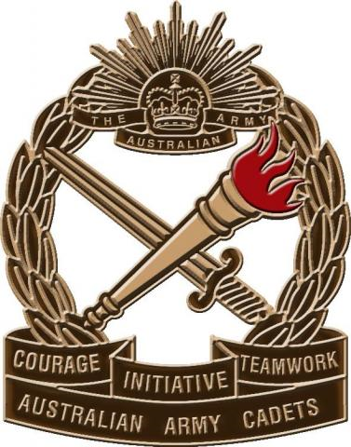**ST PAUL’S ARMY CADET UNIT SUPPORTERS’ GROUP**

**MONDAY MARCH 5TH 1800 AT THE CADET SHED**

**Attendance:**

Lea McCullock, Carole Baker, Lyn Nock, Russell Patterson, Lee Palmer, John Arnfield, Lynelle Alley, Mick Skinner, Katie Drew

**Apologies**: Nill

**AGM Order of Business**

Russell opened the meeting at 1800 and welcomed all. Mick Skinner was introduced as President of the SPS Supporters.

Russell Presented his Annual Report. Attached

Lyn Alley quickly reviewed Supporter’s financial position.

Meeting accepted the Reports as presented.

Mick Skinner then took the chair for the election of the new Executive Body.

The following were elected:

President Lea McCulloch,

Secretary Katie Drew,

Treasurer Lyn Alley.

Russell then reviewed the proposal to increase annual fees from $200 to $300. Refer Attached. Motion was carried.

Russell then wished the new executive the best, and indicated that given is interest in the Unit, he would be available as a sounding board as might be needed.

The AGM was then Closed

**Russell Patterson**

**Outgoing – President St Pauls Cadet Unit Supporters Group**

**PROPOSAL TO INCREASE CADET FEES FROM $200 TO $300 PER YEAR.**

Over the past three years, the cadet unit has seen 4 different OC’s and various adult leaders in the Administration and Support roles.

Unfortunately to some extent a lack of constancy in terms of administration and leadership has taken a toll on the unit’s effective operation and member morale.

Mrs Clare Collins as a member of the school staff and a Cadet Member parent has stepped in to the Unit Administration role.

Mrs Collins does not get released from school related teaching activities to complete these tasks.

In order to ensure that she is released on a regular basis to complete the required administration tasks, it is proposed that the unit fund one hour a week (40 Hours a year) of non contact time when Mrs Collins is not able to be tasked for alternate teaching tasks.

It expected that there will be excess funds raised from this proposal, and that those excess funds should be committed to the unit ration expenses throughout the year.

As this proposal does seek in increase in the Annual Cadet Levy that the school collects via the Term Two Fees, it will need to be voted on at the Cadet Supporters’ AGM.

Russell Patterson