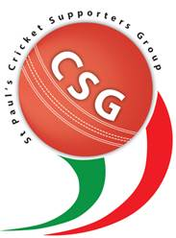

Cricket Supporters’ Group Monthly Report

* First 2017 CGS meeting held on 1st Feb
* 2016 Summer Wrap Up:
  + BNJCA season started with start of Term 3 and the St Pauls teams did well in all levels.
  + 6 teams in the competition
  + Under 8/9 teams are continuing in the post – Christmas session.
* 2017 Matters:
  + TAS cricket is underway and teams are progressing very well. Some very challenging day out in the hot weather but players are coping well and always enthusiastic to play.
  + CSG has a new FaceBook page, thanks to Mr Dylan Malloch for helping set it up.
  + Parents of the First XI are running the canteen at home games.
  + 2017 Awards Dinner Evening to be held at Kedron Wavell RSL on 25th March 6pm. We have secured the services of Australian woman’s test player Holly Furling as the guest speaker.
  + AGM dated set for Wednesday 3rd May 2016.
* Next meeting 1st March 7pm - Library