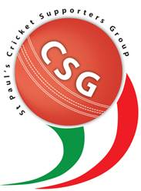

Cricket Supporters’ Group Monthly Report

* CGS meeting was held on 1st March – 9 people attended
* 2017 Matters:
  + TAS season has concluded
  + 2 boys from St Paul’s First XI were selected in the overall TAS team
  + CSG FaceBook has been a great success in keeping the families and players in touch.
  + Parents of the First XI are running the canteen at home games.
  + 2017 Awards Dinner Evening to be held at Kedron Wavell RSL on 25th March 6pm. We have secured the services of Australian woman’s test player Holly Furling as the guest speaker.
  + AGM dated set for Wednesday 3rd May 2016.
* Next meeting 3rd May 7pm - Library